2024 Candidate Filing Contact and Resource Information

2024 State of Utah Candidate Manual
Prepared by the Lt. Governor’s Office as a resource for Utah candidates.
Located online at:
Vote.utah.gov/Resources for Candidates and click on 2024 Candidate Manual.
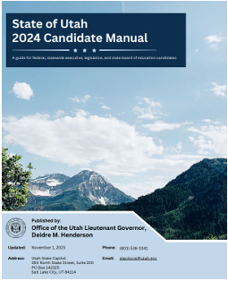

___________________________________________________
2024 State legislative and executive office declaration of candidacy forms
Multi-county legislative and executive office candidates must file at the Lt. Governor’s Office.

Candidate filing is January 2 to January 8 at 5pm.
Forms are available online at: Vote.utah.gov/Resources for Candidates and click on 2024 Filing Forms and Information.
________________________________________________________
2024 Conflict of Interest Form
This form is required BEFORE filing a declaration of candidacy for state legislative and executive offices.
Go to disclosures.utah.gov to access form.
______________________________________________
Candidate Profile
Candidates can email a candidate profile with the state prior to each election. Visit vote.utah.gov for instructions.

Primary election profile due: May 13 @ 5:00 p.m.
General election profile due: Sept. 6 @ 5:00 p.m.
______________________________________________________

2024 Candidate Filing for State legislative offices within Utah County, Utah County offices, and local school board offices Candidate Filing will be held at the Utah County Elections Division from January 2, at 8:00am to January 8 at 5:00 pm. Declaration of Candidacy forms will be provided at the election office. Candidates must apply in person.
________________________________________________________
Judicial Retention Declaration of Candidacy
Declaration of candidacy for judicial retention will be held July 1 to July 15 at the residential county of the candidate.
________________________________________________________List of Candidates, Filing Fees, and Candidate Information
The county website will list candidates as they file. Candidate qualifications, filing fees, financial disclosures, important dates and deadlines, and other candidate information can be found on the Utah County website at www.utahcounty.vote.
______________________________________________Complimentary Voter List and Has Voted Subscription
All candidates that file their declaration of candidacy in the Utah County Clerk’s office will receive a free voter list and a Has Voted subscription. A request form is included in the candidate packet.
________________________________________________________

CONTACT INFORMATION

Utah Lt. Governor’s Office
Phone: (801) 538-1041
Email: elections@utah.gov
Website: www.vote.utah.gov
Address: 350 N State St, Ste 220
Salt Lake City, UT 84114
___________________________________________________

Utah County Elections Division
Phone: (801) 851-8128
Email: elections@utahcounty.gov
Website: www.utahcounty.vote
Address: 100 E Center St, Rm 3100
Provo, UT 84606

