Forest Service LogoUSDA Logo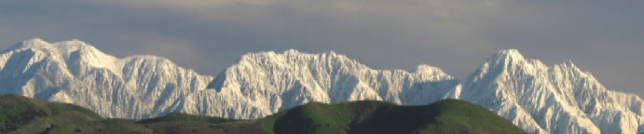

# April 27, 2018

# Forest Service

# Uinta-Wasatch-Cache National Forest

Spring is here, and the weather is warming up giving us all the desire to get outdoors.

While visiting your public lands there are a few things to keep in mind:

If you are visiting a popular location during weekends or holidays, plan ahead and allow for extra travel time. A lot of other people had the same great idea as you, and there may be traffic congestion as a result.

Don't earn a citation by parking in a no parking zone or blocking access on the roadways, emergency personnel always need to be able to get through! We want everyone to be safe and enjoy their experience. 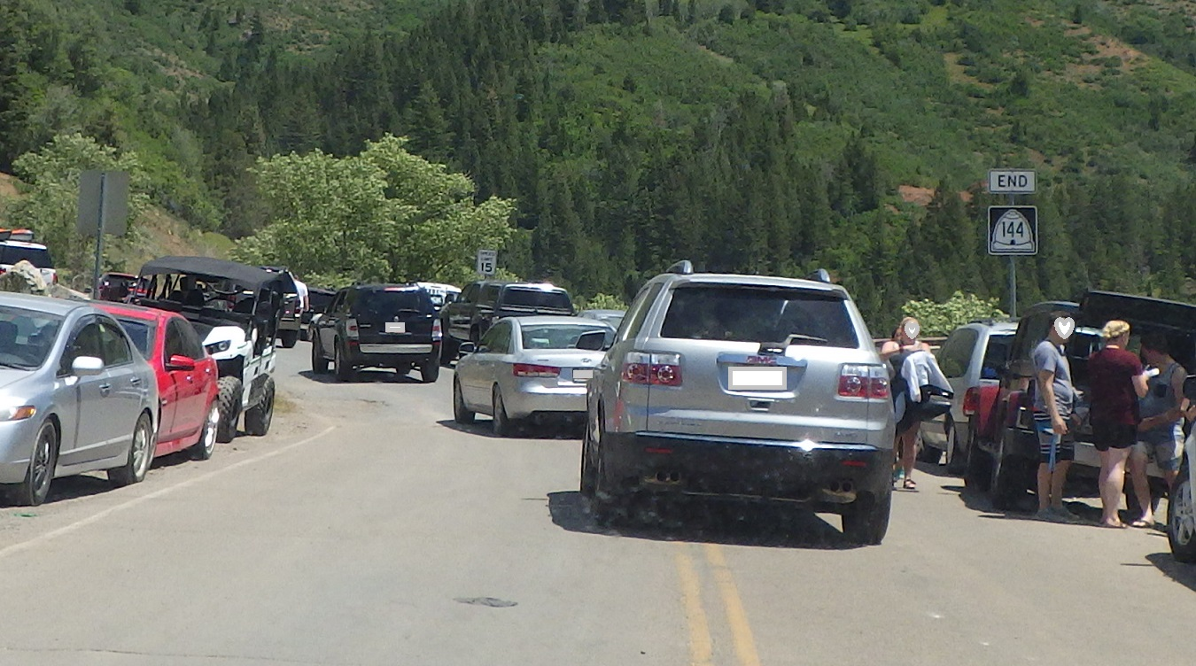

*Uh oh! The people on the right are blocking a whole lane of traffic and parking in an area that is a signed no parking zone… The people on the left, have all 4 tires off of the roadway and are legally parked, thanks for keeping everyone safe!*

Have an alternative location in mind if that area's parking lot is full. Check out our website for more information and don't forget to look at the related links section as well! <https://www.fs.usda.gov/uwcnf>

<https://www.discovertheforest.org/before-you-go/>

Pack out what you packed in and leave the area better than you found it. We are all stewards of these beautiful lands, let's work together to keep them clean!

For tips on good stewardship, check out: <https://www.treadlightly.org/learn/recreation-tips/>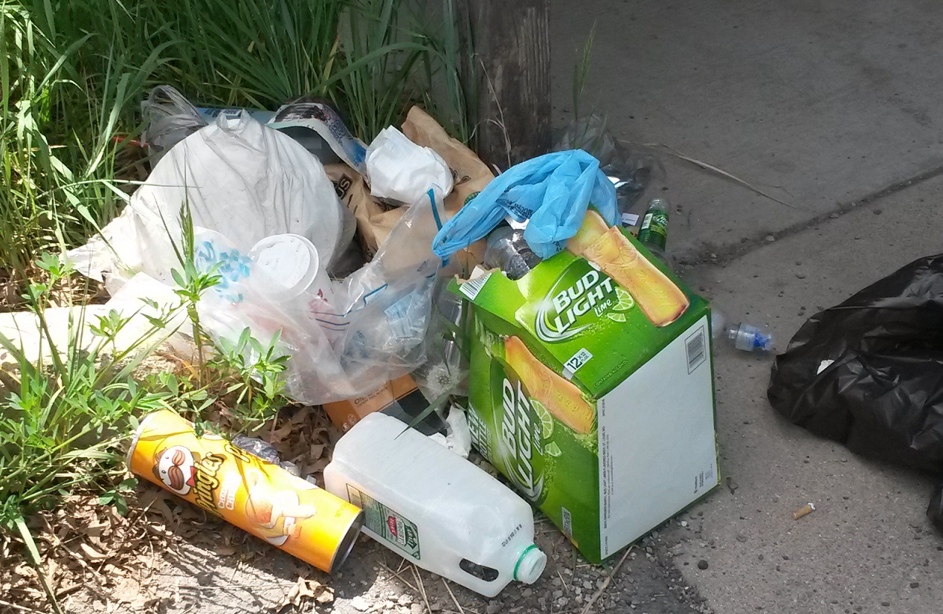

*Don't be a polluter like this person…Yuck!*

**Know before you go!** Be sure to check and see if there are any seasonal closures or fire restrictions in place before heading out to your destination.

Most importantly, relax and have fun!

Uinta-Wasatch-Cache National Forest

thinkstock

# United States Department of Agriculture